

# Objective

You will explore the RAID array and create network shares using NFS.

# Do not start VMs now.

1. **Adding disks to the server VM**

Select the *server* VM in the VirtualBox manager main window and click at the **Storage** section from the **Details** pane;

Under the **Storage Devices**, click at Controller: SATA. Then click at the **Add Hard Disk** button (the green plus sign) and select Create new disk. Choose the followings:

Hard disk file type: VDI (default)

Storage on physical hard disk: Dynamically allocated (default) File location and size: myDisk1 and 1.0 GB

Repeat the above to create another two disks called: myDisk2 and myDisk3 with the same 1.0 GB.

1. **Install RAID**

The RAID software included with Ubuntu Linux is based on the mdadm driver. Now start the *server* VM;

Identify the newly created disks

lsblk -o NAME,SIZE,FSTYPE,TYPE,MOUNTPOINT

You will have the output like the following:

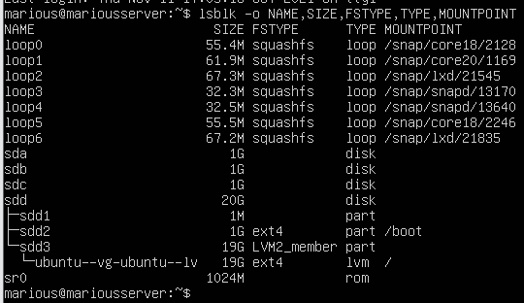

As you can see above, the sdb, sdc, and sdd are the newly created disks without a filesystem, each 1G in size. These will be the raw disks we use to build a RAID5 array.

Create the RAID5 array

Watch out: Do not use sda !然而我的sda才是新盘啊kora

sudo mdadm --create --verbose /dev/md0 --level=5 --raid-devices=3 /dev/sdb /dev/sdc /dev/sdd

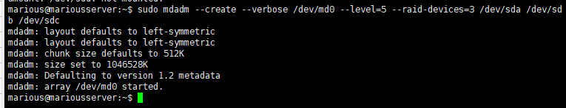

/dev/sdc /dev/sdd

The mdadm tool will configure the array. You can check the status of the array.

cat /proc/mdstat

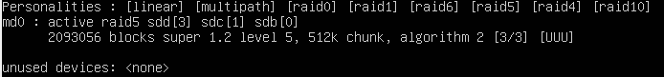

You will see the device md0 has been created in the RAID5 using sdb, sdc, and sdd disks.

Create and mount the filesystem

sudo mkfs.ext4 /dev/md0

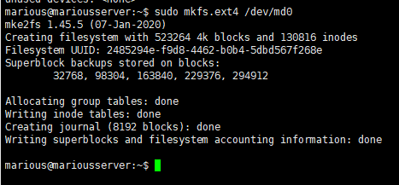

Create a mount point to attach the new filesystem

sudo mkdir /mnt/md0

Mount the filesystem

sudo mount /dev/md0 /mnt/md0

You can check the new space by typing:

df -h

You will see:

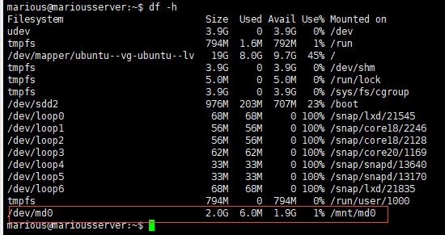

|  |  |  |  |  |  |
| --- | --- | --- | --- | --- | --- |
| Filesystem | Size | Used | Avail | Use% | Mounted on |
| /dev/md0  Check the disks again | 2.0G | 6.0M | 1.9G | 1% | /mnt/md0 |

lsblk -o NAME,SIZE,FSTYPE,TYPE,MOUNTPOINT

You will see that the three disks in the RAID array mounted at /mnt/md0 have the linux_riad_member type for the disks and ext4 filesystem on the partition md0 as the raid5 type. Note that the RAID 5 array has a capacity of 2GB instead of the total capacity of 3GB of all three disks.

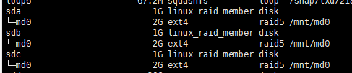

Save the RAID array layout for automatic assembling and mounting at boot

To make sure that the array is reassembled automatically at boot, append the array configuration to /ect/mdadm/mdadm.confecho

sudo mdadm --detail --scan | sudo tee -a /etc/mdadm/mdadm.conf sudo update-initramfs -u

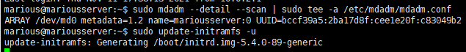

Add the new filesystem mount options to the /etc/fstab file for automatic mounting at boot

echo '/dev/md0 /mnt/md0 ext4 defaults,nofail,discard 0 0' | sudo tee -a /etc/fstab



Create a file in the storage space

cd /mnt/md0

sudo pico readme.txt

enter the text: "This is my storage on RAID5.", save and exit.

ll

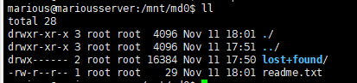

You will see the file readme.txt is created.

1. **Create a Network File System (NFS) share**

Continue work on your server VM. Update the system

It is a good practice to update your system each time before you install a package.

sudo apt update sudo apt upgrade

Install NFS server

sudo apt install nfs-kernel-server

Configure the exports

Add the following line in the file /etc/exports using pico.

这里就很有意思，傻逼word标红了下划线导致我没看到

/mnt/md0 *(rw,sync,no_root_squash)

Start the NFS server

sudo systemctl start nfs-kernel-server.service

Reboot the server VM

sudo reboot

1. **Connect the NFS share from the *desktop* VM**

You can connect to the NFS server to browse and use files on the server as if they were on the local computer.

Now start the *desktop* VM.

Install the NFS client from the Terminal

Update the system

出现没有release



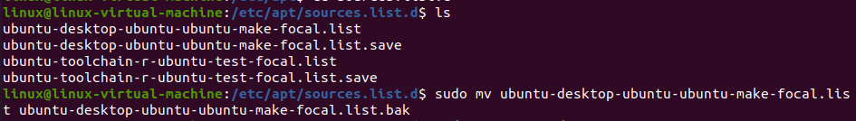

sudo apt update sudo apt upgrade

Install the NFS client

sudo apt install nfs-common

Check the list of shares on the server

showmount -e server.abc123.test



You will see that the share /mnt/md0 is listed.

Mount the NFS share Create a mount point

sudo mkdir -p /share/md0

Mount the NFS share

sudo mount -t nfs server.abc123.test:/mnt/md0 /share/md0

List the files on the share

ll /share/md0

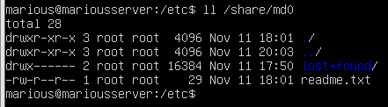

You will see the readme.txt file you created on the server. Display the content of it.

cat /share/md0/readme.txt



Create a file in the new filesystem

sudo pico /share/md0/fromdesktop.txt

enter the text: "This is from desktop VM", save and exit.

ll

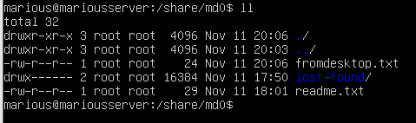

You will see the file fromdesktop.txt is created. Access the file from the *server* VM

On the server,

ll /mnt/md0

You will see the file fromdesktop.txt listed. Display the content of it.

cat /mnt/md0/fromdesktop.txt



Mount the NFS share at boot

Add the following line to the end of the /etc/fstab file:

server.abc123.test:/mnt/md0 /share/md0 nfs defaults,user,exec 0 0

1. **Simulate a disk failure in the RAID array on the server VM**

View the status

To view the status of an array:

sudo mdadm -D /dev/md0

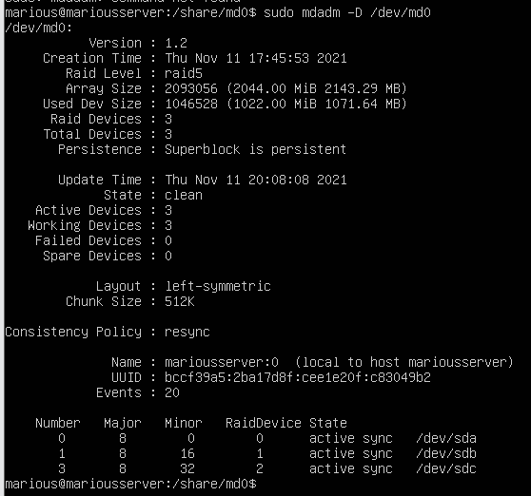

To view the status of a disk in an array:

sudo mdadm -E /dev/sdd

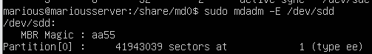

Simulate a disk failure in the RAID array

Shutdown the server VM (not power off but ACPI shutdown by sending shutdown signal). Select the *server* VM in the VirtualBox manager main window and click at the **Storage** section from the **Details** pane;

Under the **Storage Devices**, click myDisk2.vdi and press the Remove selected storage attachment button (a disc with red minus sign).;

Start the server VM again;

Reassemble the array with a disk failure

sudo mdadm --stop /dev/md0

sudo mdadm --assemble --force /dev/md0

View the status of the array again:

sudo mdadm -D /dev/md0

Now, there are only 2 **Active** devices with the array **state** as clean, degraded.

Display the file on the RAID5 array with a disk missing

cd /mnt/md0 ll

cat readme.txt

The files are intact and accessible.



Add a new disk to replace the failed disk in the RAID array

Shutdown the *server* VM and follow the steps in the Section 1 to add new disk called myDisk4

to the *server* VM; Start the *server* VM; Identify the new disk:

lsblk

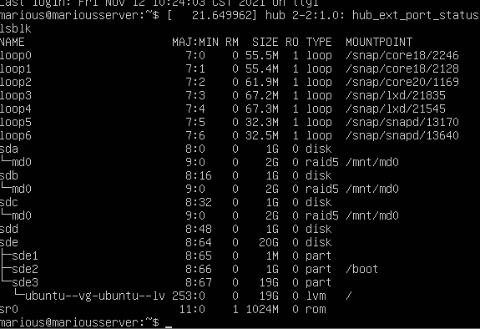

The new disk is likely /dev/sdc.貌似sdd

Add a new disk to the array

sudo mdadm --add /dev/md0 /dev/sdc



This will cause the drive to re-sync with the array. It will normally take a considerable time to complete. you can use the command cat /proc/mdstat to check the progress. In our case, it completes instantly as the disk is only 1GB in size.意思就是大磁盘其实很耗时间

View the status of the array:

sudo mdadm -D /dev/md0

Now, there should be 3 **Active** devices with the array **state** as clean.

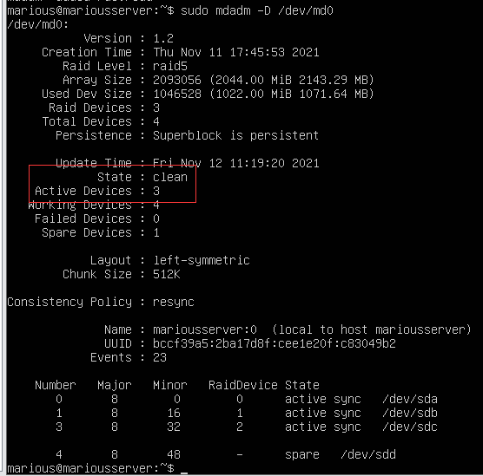

# Submission and mark

Show your work to the teacher. Of 6 marks, you can get

1.5 for showing the content of /etc/mdadm/mdadm.conf on the server VM;

1.5 for showing the content of /etc/fstab on the server VM;

1.5 for listing the files in the directory /share/md0 on the desktop VM;

1.5 for showing the new disk called myDisk4.vdi for the server VM in the VirtualBox manager.

You should be ready to answer any questions to demonstrate that all work is done by yourself otherwise you may receive 0 mark.

IMPORTANT NOTE: You will need to document all of your lab work in your wiki.